Emotion Based Music Recommender Using Machine Learning

***Mrs.Swathi Turai¹, Rushmitha Arellii², Huda Nazneen³, Pradeep saranga⁴, Sai Prabhas Vudgula⁵***

*¹ Assistant Professor, Dept. of CSE-Data Science,ACE Engineering College, India*

*²³⁴⁵ B.Tech CSE-Data Science,ACE Engineering College, India*

*Emails:swathiturai12@gmail.com,rushmithaarelli05@gmail.com,nazneenhuda9@gmail.com, sarangapradeep26@gmail.com,prabhasnane@gmail.com*

A B S T R A C T

The Emotion-Based music recommender system that detects a user’s emotional state using facial expression or manual text input to suggest songs that align with their mood.Facial emotions are detected via webcam using image processing and a trained CNN model,while text input allows user to type their feelings.Based on the emotion detected and user preferences(language,platform) suitable music is recommended through platforms like YouTube etc. The system is build using Python, OpenCV, MediaPipe and PyQt5, and includes a feedback mechanism to refine emotion detection.This system enhances user experience by offering a personalized music journey and supports emotional well-being by recommending mood-specific songs, acting as a potential tool for music therapy.

Keywords: Emotion detection, Music Recommendation, Feedback,Facial Expression recognition, pre-trained CNN, Text-based input, PyQt5, OpenCV, MediaPipe, deep Learning, Music tools, Mental well-being, Personalized music system.

# 1.Introduction:

Most music recommendation system rely on user history such as previous song plays or search patterns.While effective to some extent , they do not consider the user’s real-time emotional state,which significantly influences music preferences.This can lead to recommendations that feel disconnected or irrelevant to the user’s mood.

To solve this , we developed an Emotion-Based Music Recommender system that uses facial expression or manual text input to detect a user’s current emotion and suggest suitable songs.Using a webcam, the system captures facial features and classifies emotions such as happy,sad etc through a pre-trained CNN Model. Users can also manually enter their mood . Based on the emotion, platform, and language selected, songs are recommended via YouTube or spotify. The application, build using PyQt5 and OpenCV, provides a seamless and interactive user experience focused on personalization and emotional well-being.

# Literature Review:

Emotion-based recommendation system offer a more personalized experience by adapting content to a user’s current mood.Traditional system often rely on collaborative filtering or past user behaviour but fail to consider real-time emotions, which are critical in music preference. To address this, Modern emotion-aware systems leverage various inputs such as facial expressions, vocal tone, or physiological cues for accurate mood detection. This project focuses on facial expression-based detecting using computer vision and machine learning.

The emotion classification model in this project is built using keras and trained on facial and hand landmarks captured through MediaPipe. A total of 1020 features are extracted to represent user experience. Similar approaches were explored by Tang(2013) [1], who used CNNs for facial emotion recognition on datasets like FER2013.

In music recommendation, system such as Spotify use behavioral history, while researchers like Baltruns(2011) and Kim et al.(2010) explored context-aware and physiological single-based suggestions. This project recommends music genres aligned with the detected mood, such as calm tracks for sad emotions and energetic music for happy states. Although limited to facial input, Future improvements may include multi-modal data for better accuracy, as supported by Zhou et al(2017).

# Methodology:

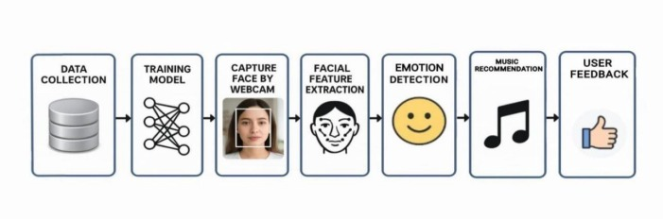

**Fig 1.Methodology of Emotion-Based Music Recommendation System**

The proposed system uses emotion detection to generatepersonalized music recommendations.The methodolgy is divided into three major phases **:Emotion Detection, Music Recommendation and Feedback**

As shown in fig 1, the process begins when the user selects either camera or text mode through the application’s graphical interface. In the camera mode, the system captures a live video feed of the user’s face using OpenCV. MediaPipe Holistic is then applied to detect facial and landmarks,This model classifies the user’s emotion into categories such as Happy, Sad etc. In the manual mode, user can input state directly into the application.Once the emotion is detected, the system maps it to a corresponding music category based on user selected language and preferred music platforms.then a song is recommended and user is redirecting to the the platform .A feedback system allows users to confirm or correct the detected emotion, storing the result to enhance future predictions.

This methodology ensures a personalized, adaptive, and emotionally aware music recommendation experience, combining computer vision, deep learning , and user feedback into a seamless system.

* 1. **System Architecture**

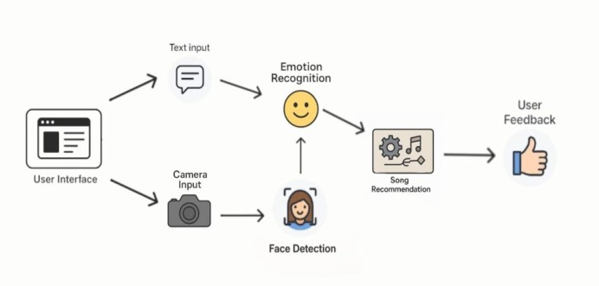

**Fig 2 : System Architecture**

The architecture of the Emotion-Based Music Recommender System is a user-centric, modular flow that ensures a seamless and personalized music experience using emotion recognition technology.The entire process is divided into into five primary modules, each responsible for a specific function in the workflow. The system is lightweight, GUI-based, and suitable for real-time music suggestions.

1. User (Listener)  
    The user initiates the process by interacting with the system through a graphical interface developed using PyQt5. They are the central participants who selects the input mode (camera or text), provides language/platform preferences, and receives the recommended music.
2. Input Module  
    The user chooses between two input modes: webcam or text. In camera mode, OpenCV activates the webcam to capture live video of the user's face. In text mode, users manually input their current emotional state.
3. Emotion Detection Module  
    For camera input, MediaPipe Holistic extracts facial and hand landmarks, which are converted into a fixed-size feature vector. This data is passed to a pre-trained Keras model that predicts the user's emotional state (e.g., Happy, Sad, Angry, or Neutral). For text input, the provided emotion is directly used.
4. Music Recommendation Module  
    Once the emotion is recognized or entered, the system maps it to a predefined set of music categories. Based on the emotion, language, and platform preference (YouTube, Spotify, or Apple Music), a music search query is constructed and launched in the default browser.
5. Feedback System  
    After emotion prediction, the user is prompted to confirm its accuracy. This feedback is stored in a local JSON file and used to refine the model's performance by adjusting for recurring misclassifications.

· This architecture enables intelligent, real-time music recommendations while offering both automation and manual control. Each module functions independently yet works in sequence to provide a cohesive and responsive user experience.

# Output Screens :

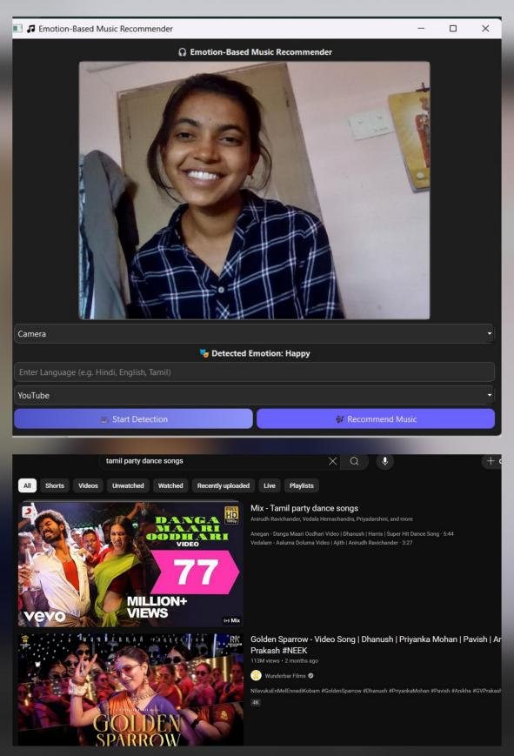 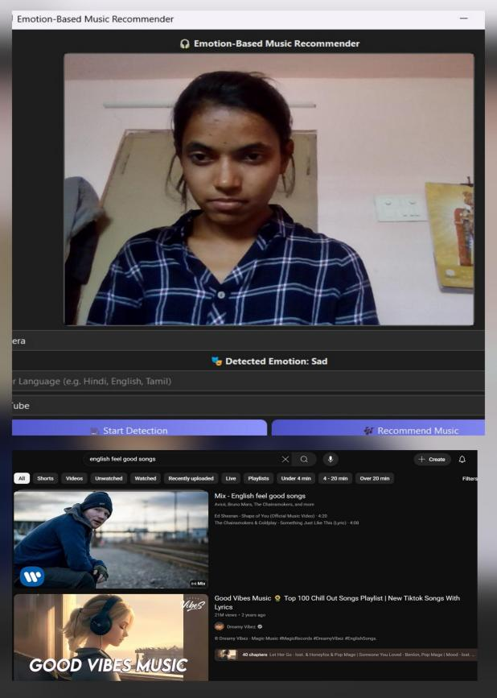

**Fig 3 . Input Mode : Camera Fig 4 . Emotion Detected**

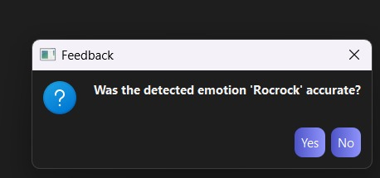

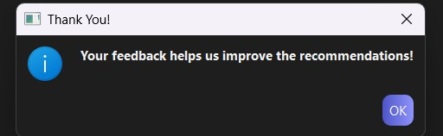

**Fig 5. Feedback**

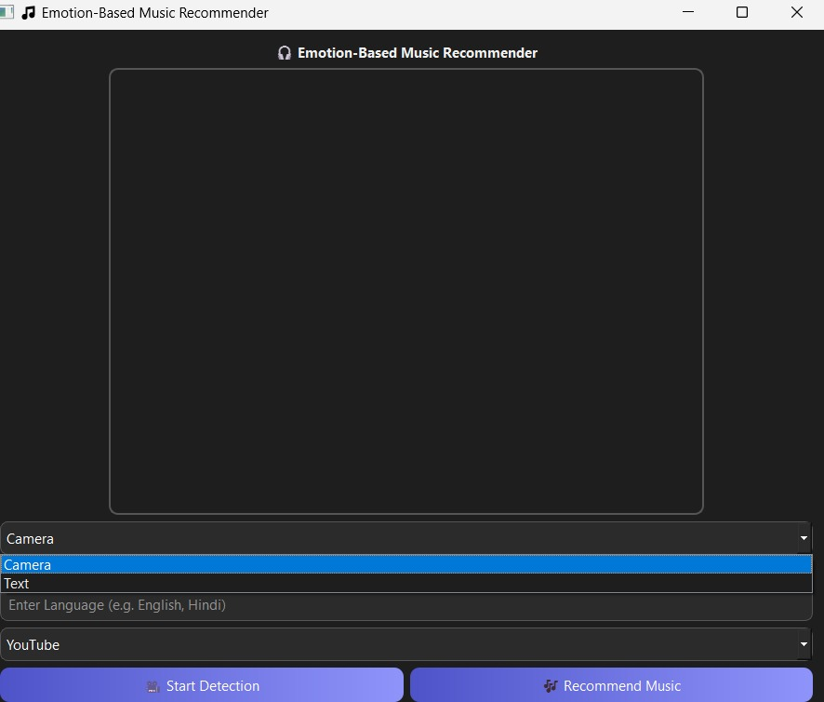

**Fig 6.Input Mode : Text**

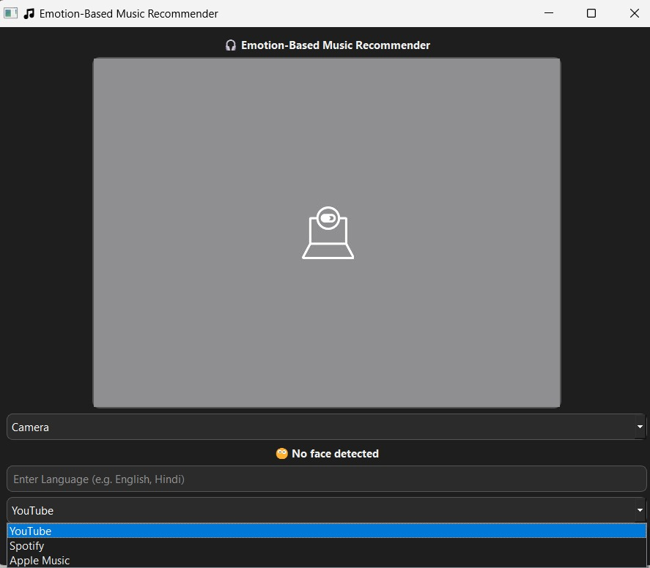

**Fig 7 .Emotion Detected**

# 5. Work Flow

The Emotion-Based Music Recommender System follows a structured pipeline that integrates facial emotion detection and GUI-based interaction to offer personalized music recommendations in real time. The complete workflow is detailed below

Step 1: Launch the Application

- User selects between"Camera"and"Text"modes.

- In camera mode,webcam is activated in text mode,user inputs an emotion manually.

Step 2: Face Detection

If using the camera,MediaPipe detects facial landmarks from the video stream.

Step 3: Emotion Prediction:

- Landmark data is processed and passed to the Keras model.

- Predicted emotion is displayed.

Step 4: Music Recommendation

- User enters language preference and selects a platform.

- Application launches a browser tab with a search query tailored to the user's mood and preferences.

Step 5: Feedback Mechanism

-After prediction,the user is prompted for feedback.

-If marked inaccurate,the feedback is recorded and used in future predictions.

Step 6: Output

The final output is a live display of detected faces, their corresponding emotions, and Song Recommendation. This workflow ensures the system continuously detects faces, classifies emotions, and provides real-time feedback and song suggestions.

# 6. Conclusion and future scope:

The Emotion-Based Music Recommender project introduces an intelligent multimedia recommendation system that uses facial emotion recognition to overcome the limitations of traditional behavior-based music recommendation models. It achieves:

* A real-time, emotion-aware music suggestion experience using facial expression recognition or manual input.

*Accurate emotion classification using deep learning and facial landmark detection techniques.

* Platform-agnostic music recommendations via YouTube, Spotify, or Apple Music based on emotion and language preferences.

* Improved personalization and user satisfaction through adaptive, context-sensitive recommendations.

* A feedback mechanism that enables the system to self-improve based on user responses, enhancing long-term accuracy.

* End-to-end integration of modules like emotion detection, feedback processing, and platform redirection into a cohesive, real-time system.

**Future Scope:**

**1.Multi-modal Emotion Detection:**

Integrate audio, gesture, and text-based sentiment to improve recognition accuracy and adapt to various contexts

**2. Emotion-to-Genre Dataset Development :**

Create a large-scale emotion-genre mapping dataset to fine-tune recommendations and support clustering-based personalization.

1. **Timeline-based Emotion Tracking:**

Implement emotion state tracking over time to recommend song sequences that stabilize or uplift mood dynamically.

**4. Wearable Integration:**

Incorporate data from wearables like smartwatches (e.g., heart rate) for a holistic understanding of user emotions

**5. Voice Input Support:**

Enable natural voice-based emotion input using speech recognition and natural language processing.

**6.Expansion to New Music Sources:**

Add support for other platforms like Amazon Music, Gaana, and JioSaavn to offer users greater variety.

This conclusion and future scope advocate for the Emotion-Based Music Recommender as a scalable, emotion-aware, and future-ready system in intelligent multimedia recommendation.

# 7. Acknowledgement :

We express our sincere gratitude to all who supported us throughout the development of this project.We are especially thankful to Prof. Y.

V. Gopala Krishna Murthy, General Secretary, and Mrs. M. Padmavathi, Joint Secretary, for providing us the opportunity and environment

to carry out this work.Our heartfelt thanks to Dr. P. Chiranjeevi, Head of the Department, for his guidance and encouragement.We are

deeply grateful to our internal guide Mrs.T.Swathi , and project coordinator Mrs. B. Saritha, for their consistent support, valuable

feedback, and motivation throughout the project.

Lastly, we thank all the faculty members, staff for their constant encouragement and support.

# 8. References :

[1]Emanuel I.Andelin and Alina S.Rusu,”Investigation of facial micro expressions of emotions in psychopathy-a case study of an individual in detention”,2015,Published by Elsevier Ltd.

[2]Paul Ekman,Wallace V Friesen,and Phoebe Ellsworth.Emotion in the human face:Guidelines for research and an integration of findings.Elsevier 2013.[3]F.De la Torre and J.F.Cohn,“Facial expression analysis,”Vis.Anal.Hum.,pp.377–410,2011.

1. Zhang,Z.Feature-based facial expression recognition:Sensitivity analysis and experiments with a multilayer perceptron.International Journal of Pattern Recognition and Artificial Intelligence.
2. “Emotion-Based Music Recommendation Using Facial Expressions and Lyrics with Deep Neural Networks”,19th International Society for Music Information Retrieval Conference,Paris,France,2018.